The Land Collective
Advisory Board Information Pack 2022-2023

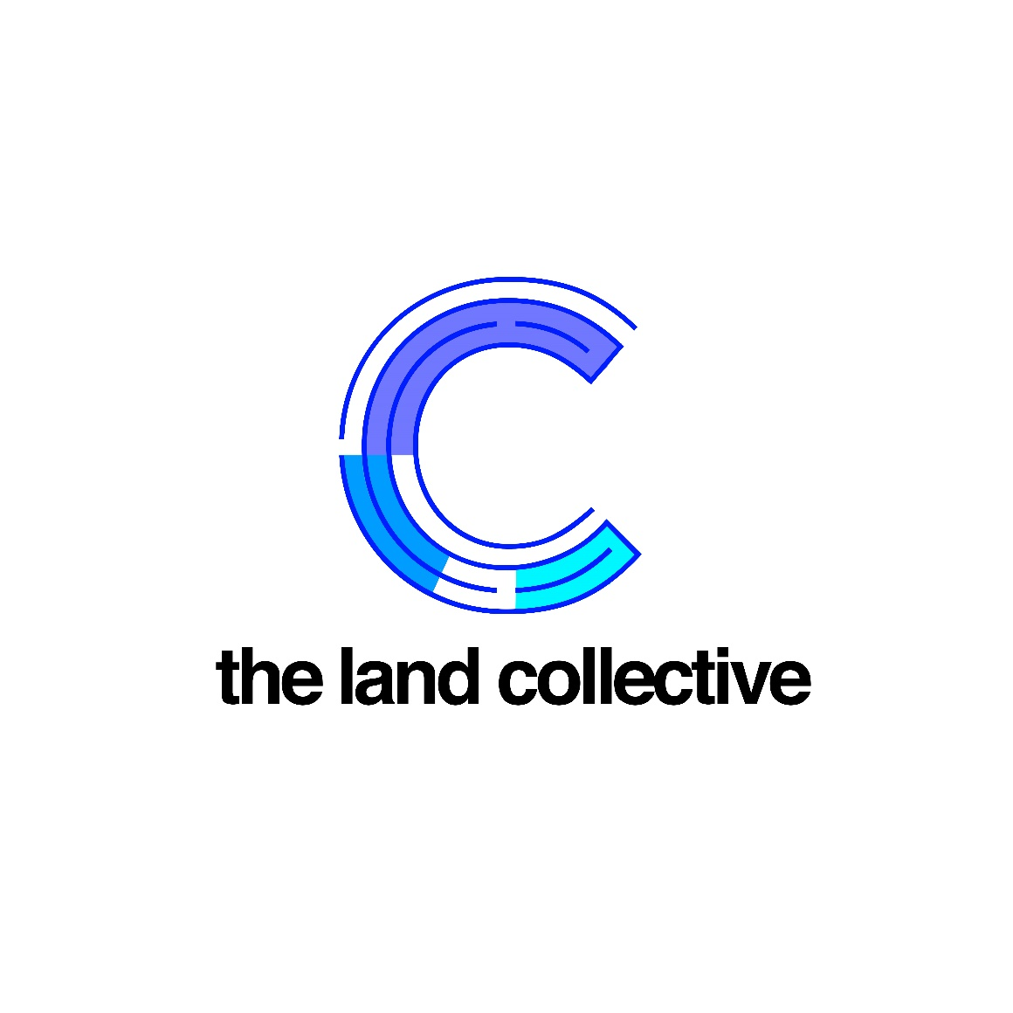

Welcome Message
Thank you for expressing interest in joining the Board for The Land Collective, it has been a challenging and exciting journey in running the enterprise, and I hope that you can also be part of it.
The Land Collective was started by myself whilst in university, what started off as a blog to rant about local issues, quickly snowballed into an online platform that advised on career options and opportunities, provided commercial awareness and also gifted young people with a platform to voice their thoughts and opinions online in a progressive, professional and critical manner.
Our focus at The Land Collective is to engage and educate more young people with the built environment sector by ways of digital media, networks, and events. To date, we are still the only brand that does this in the sector.
If you have a passion for inspiring and uplifting the next generation, an enthusiasm for the built environment sector and the skillset to help us grow, it would be amazing to hear from you.

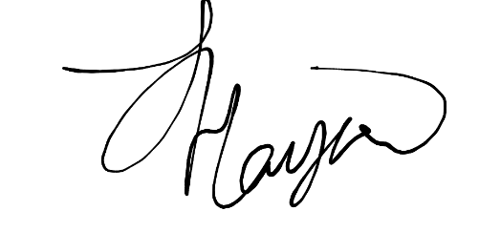

Sarah Hayford
CEO & Founder

About Us
The Land Collective is a content-led initiative that was started in 2017, to encourage more young people between the ages of 16 and 25, to engage with the built environment sector, through media, journalism, events, and employment opportunities.
We pride ourselves on growing online with a diverse team of volunteers, who come from various backgrounds which include architecture, economics, politics, law and real estate.
The Land Collective are very vocal and active on social media and have built a network of engaged students and graduates who we communicate with regularly.

Our Core Values
The Land Collective wishes to:
Voice - allow young people to voice their opinions critically, in a healthy manner without judgement,
Educate - teach and engage more young people about the sector in a holistic manner,
Inspire - encourage more young people from disadvantaged backgrounds to take an interest in the built environment sector.

How Do We Aim to Reach Young People?
The Land Collective reaches out to young people in numerous ways and hope to expand this going forward with the use of grant funding. Here are some of the ways we have been doing so, and how we wish to move forward.
Career & Employability Workshops
To introduce or reintroduce more young people to job opportunities and pathways across the sector. As we realised after extensive research only 10% of students are aware of job opportunities in property.
Informative & Interactive Events
Provide free and engaging events for those who want to develop their commercial awareness, networking skills and learn more about the sector holistically. We want to remove elitism and exclusivity from the sector.
City Tours
Working in collaboration with developers and companies across the sector to provide city tours, which allows for more young people to appreciate the built environment and understand what is happening in their local areas.
Virtual Internship Programmes
Following the success of our first virtual internship programme in August 2020 in response to the pandemic, we would like to replicate it over the coming years across different built environment disciplines, giving more students the opportunity to build on their experience in a non-traditional manner.

Writing Competitions
We want to encourage more young people to voice their opinions online in a constructive and critical manner and would like to host writing competitions with small cash prizes, sponsored courses and/or internship opportunities to uplift them. These will be aimed at 18-21-year olds. We launched our fist Writing Competition in December 2020, in partnership with Bayfield Training.
Student Ambassador Programmes
We want to build our on-campus presence and want to support extra-curricular activities through student ambassador programmes. These students will be encouraging their peers to read our content, contribute and host events.

How Are We Funded?
The Land Collective has been personally funded by the founder since its inception. In December, The Land Collective was formally registered as a Community Interest Company. In the future, we hope to utilise the following funding methods to keep the initiative and organisation running.

Grant Funding
We hope to build relationships with different grant funding providers to assist us financially, so that The Land Collective can grow its core team, and exercise our missions as stated above.
Company Sponsorships
As we have been operating in the industry for quite some time, we hope to further grow our footprint and form relationships with companies across the sector, in order to sponsor our work, efforts and commitments toward a more diverse sector.
Sponsored Programmes
Throughout the year, we host topical and employability programmes that employers across the industry are able to sponsor and support.
Job Boards & Recruitment
We offer direct job promotion and recruitment services to employers in the sector that cover apprenticeships, placements, internships graduate programmes and entry-level jobs.

Being a Board Member
As a Board Member you will:
- Be an ambassador for The Land Collective and for our work.
- Help shape the strategic direction of The Land Collective ensuring we are meeting our objectives.
- Make sure that caring together has policies in place which comply with current legislation and promote good practice.
- Contribute to the setting of goals and targets and evaluating performance against them.
- Ensure the effective management of risks.
- Support the income generation and outward facing activities of The Land Collective.
- Spend time with different elements of our organisation and understanding our work.
- Safeguard the good name and values of The Land Collective.
- Participate in the cycle of meetings and ensure decisions taken at meetings are implemented.
- Attend any training and development sessions to promote your knowledge and development in the role of Board Member.

As a Board Member you will need
- To be committed to developing your knowledge and understanding of how The Land Collective is run.
- To be committed to supporting and promoting The Land Collective’s vision and values.
- To understand and firmly believe in the work we do.
- To demonstrate strong leadership skills.
- To be a creative thinker and help The Land Collective develop areas of work.
- To have excellent communication skills and be able to both build agreement and challenge constructively.
- To be passionate about youth development, empowerment, and engagement in the built environment sector.
- To be an active member of the board, committing the time and thought needed.
The Board
We aim to hold four quarterly board meetings per year (March, June, September, December), plus strategy and community engagement and individual support days.
We are currently seeking Board Members who have the following experience/interests; however, all are welcome to apply and interview.
Student/Graduate
We would like to hear from current students or recent graduates on how we can approach more universities and reach students on campus from different disciplines for our projects. Alternatively, if you have worked in schools or colleges, we welcome you to apply also.
Safeguarding
We would like to hear from people with safeguarding experience to ensure that our staff and stakeholders are protected and kept safe from a company perspective. It would be ideal for this candidate to have over 3 years of safeguarding experience.
Fundraising
We are keen to hear from individuals who have fundraising and bid writing experience as it pertains to grants. Grant funding will be a large part of our income moving forward and it’s vital that we have someone onboard who understands this process and can help us navigate this properly.

Time Commitment
Board Members are asked to prepare for, attend and contribute to all board meetings and join sub-committees, steering groups and ad hoc task and finish groups as required. Meetings will be held online until further notice, with some meetings held in-person in London.
We estimate that an annual commitment for our trustees is c. 6-8 days per year in total.
Remuneration
The position of Board Member is unpaid. However, all reasonable out of pocket expenses incurred on charity business will be reimbursed in line with our expenses policy.

Term of office
Board Members are appointed for an initial term of three years, with the possibility of extension for two further periods of three years.

Induction and Support
Once appointed, Board Members will be given an induction programme which will involve getting to know the organisation and becoming familiar with the role of Board Member if appropriate. You will also be offered regular meetings with the chair.
We are committed to making the role of Board Members a positive and mutually beneficial experience and welcome feedback on how we can continue to improve our governance processes.

Next Steps
We want to give you the opportunity to find out more about the role of a Board Member, and whether you feel it is right for you, without going through a lengthy or complicated application process. If you are interested in applying, or would like to find out more:
Contact Sarah Hayford, Founder and CEO at Sarah.h@thelandcollective.com to organise a chat.
We will be holding interviews on an ongoing basis throughout July and August, with the aim of making appointments by the beginning of September 2022.

